High level design

[Project]

**Technology stack:**

1) Server part - Python (+ TF + Keras libraries)

2) Web - Flask Microframework, JavaScript

3) Auxiliary – Github, Trello

**Data flow diagram:**

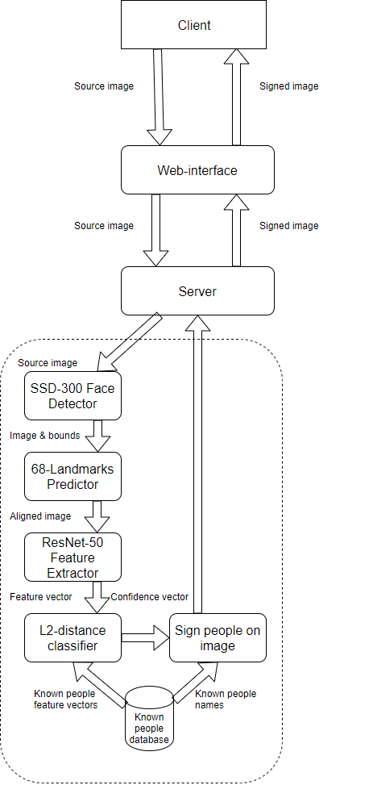

**Sequence diagram**

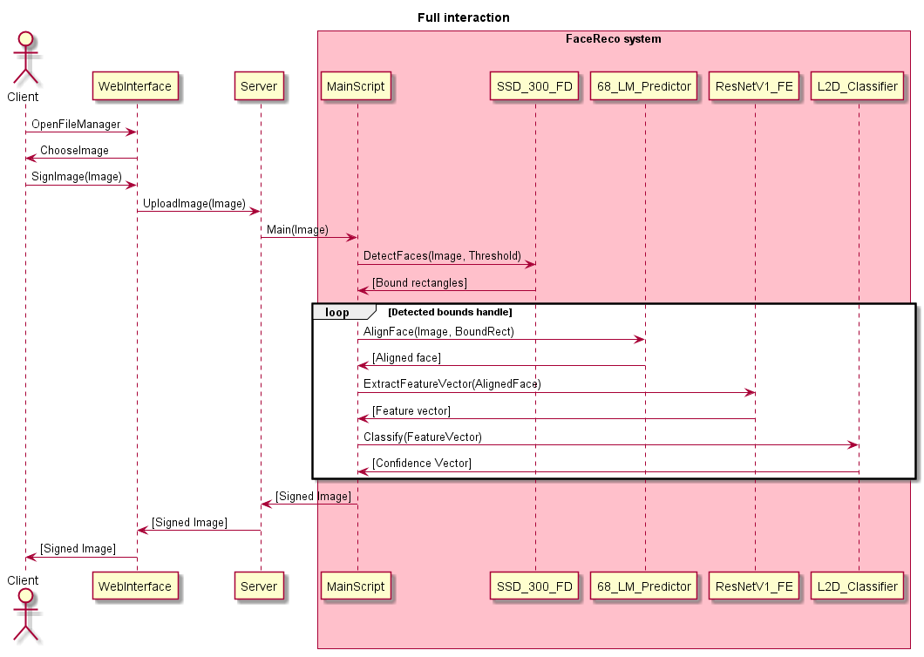

**Adapters:**

1. Cutting bboxes received from face detector with small confidence to get rid of false faceboxes (10 python lines)
2. Converting received faceboxes into the dlib.rectangles to use it for 68-LandMarks predictor (1 python line)

**Original code**

L2-Distance classifier implementation (20 python lines)